DAILY ONLINE ACTIVITIES SUMMARY

|  |  |  |  |  |  |  |  |
| --- | --- | --- | --- | --- | --- | --- | --- |
| Date: | 28-05-2020 | | | | Name: | GUDUGUNTI ANIRUDH | |
| GUDUG | IV - A | | | | USN: | 4AL18CS023 | |
| Online Test Summary | | | | | | | |
| Subject | | Microcontroller and embedded systems and Vyavaharika kannada | | | | | |
| Max.  Marks | | 20,50 | | Score | |  | |
| Certification Course Summary | | | | | | | |
| Course | Python in ML | | | | | | |
| Certificate Provider | | | Great learning academy | Duration | | | 2hrs |
| Coding Challenges | | | | | | | |
| Problem Statement:1. Digital root of a number.  2. Counting number of vowels in each substring of a string. | | | | | | | |
| Status: Executed | | | | | | | |
| Uploaded the report in Github | | | | Yes | | | |
| If yes Repository name | | | | https://github.com/Anirudh23-23/Daily-progress | | | |
| Uploaded the report in slack | | | | Yes | | | |

Online Test Details:

**MES:** The online test was from module 2 which was about the introduction to ARM instruction set and ARM programming using assembly language. There were 20 questions and the duration was 40 minutes. The questions were optimal and were easy. The score that I got in the test is 18 /20.

**Vyavaharika Kannada:** The online test was from all the five chapters. All were objective type questions and were optimal. There were 50 questions and the duration was 50 minutes. The score that I got is 46/50.

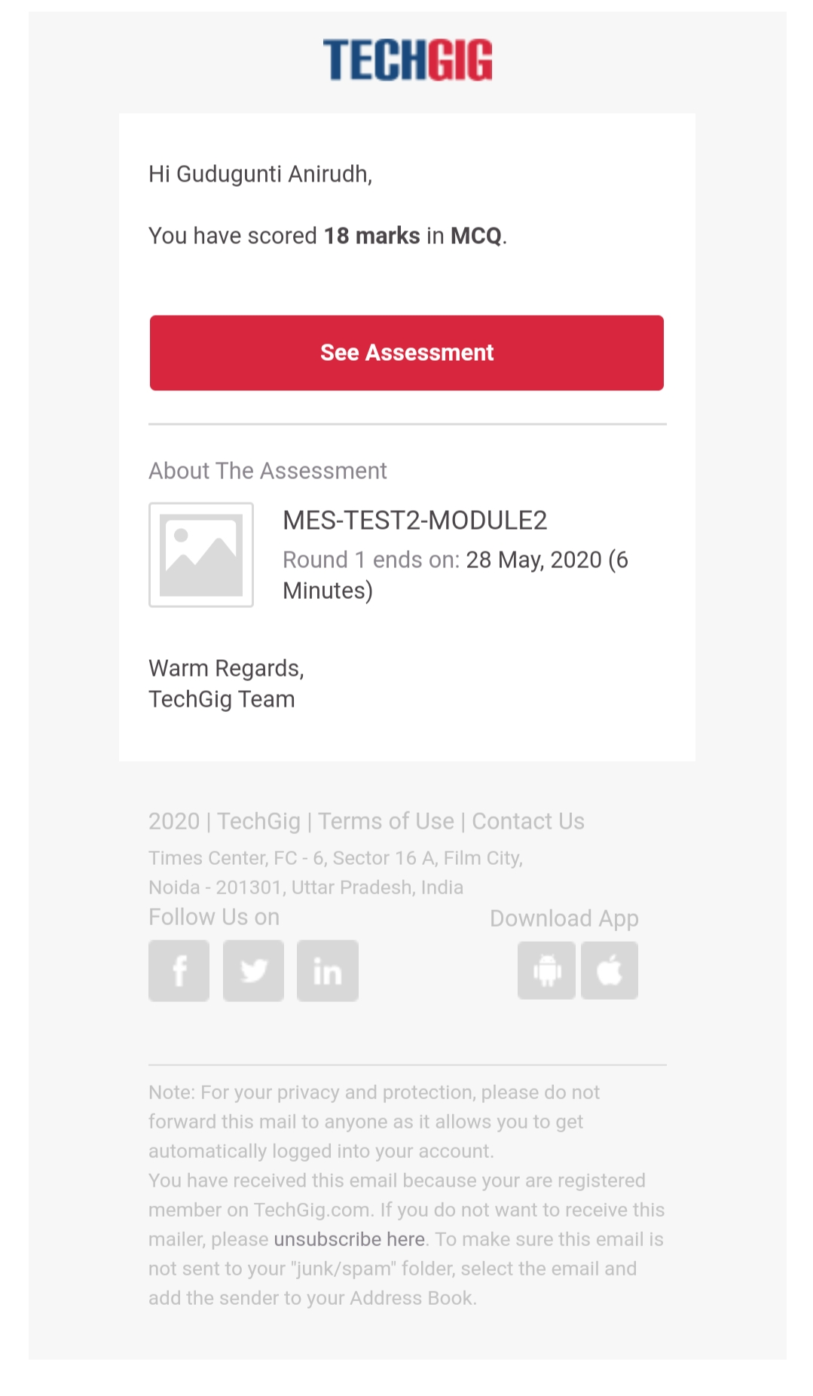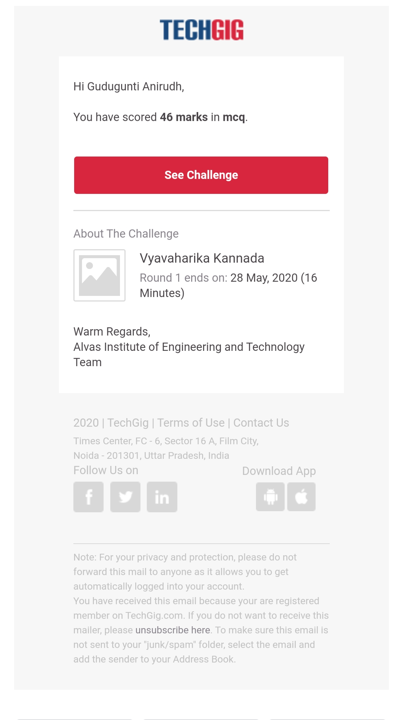

Certification Course Details:

1. Worked out examples on NumPy.

2. Examples on mathematical functions like matrix, vectors and many other.

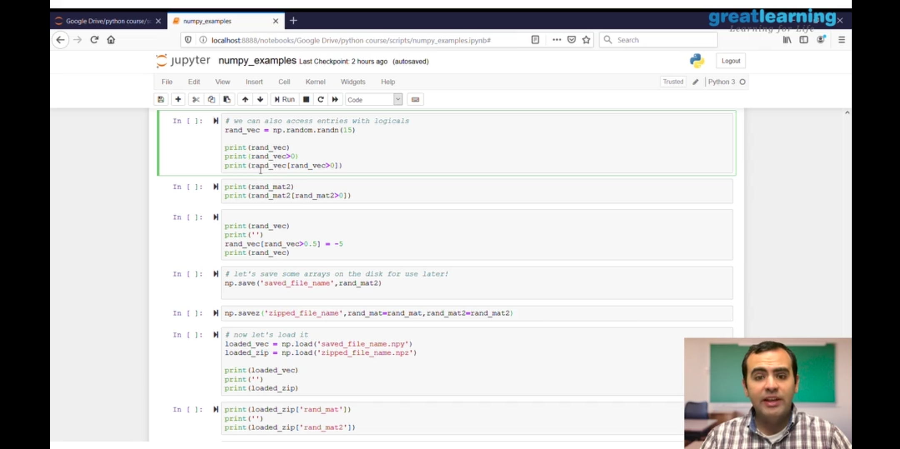

Coding Challenges Details:

Problem 1: (using C language) Write a program to print the digital root of a number.

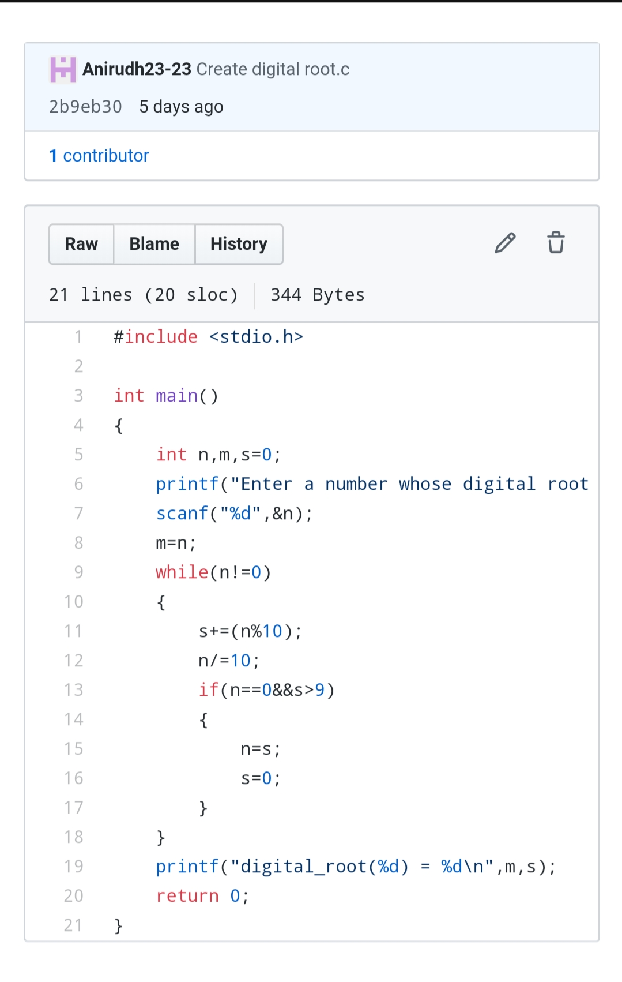

Problem 2:n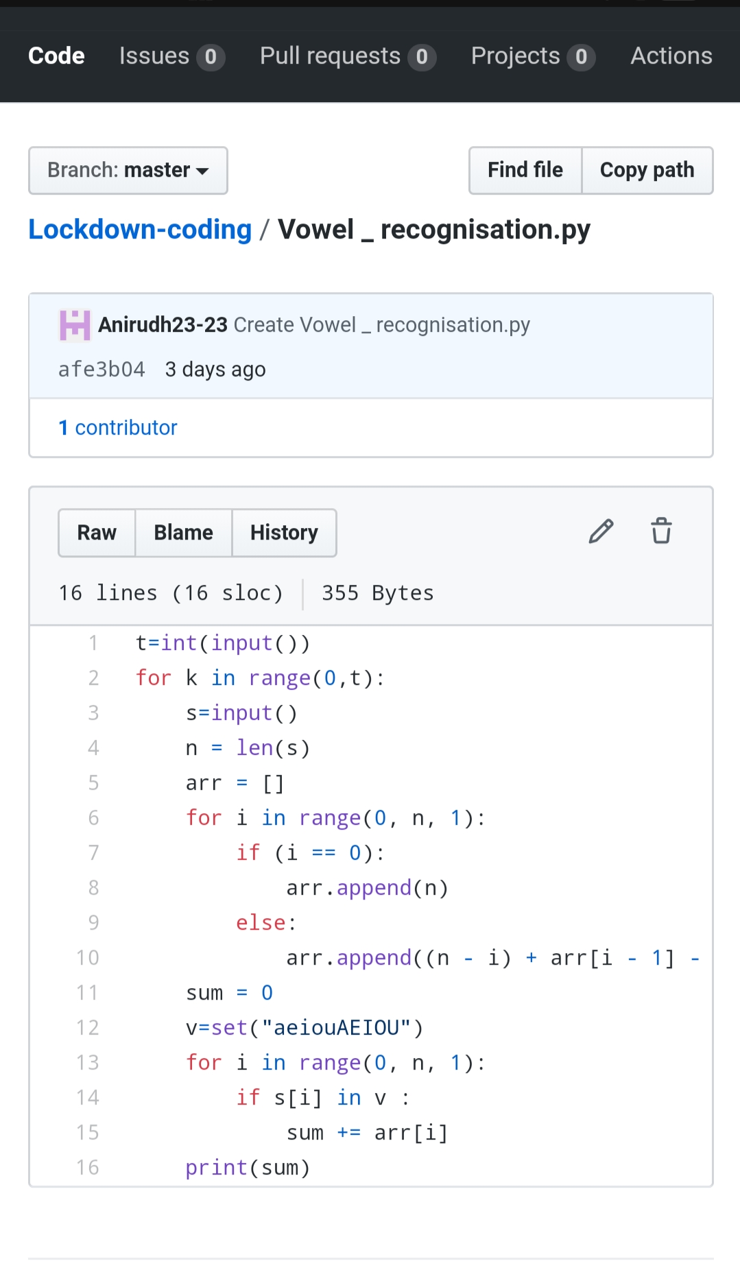umber of vowels.